VILNIUS UNIVERSITY

KAUNAS FACULTY

INSTITUTE OF SOCIAL SCIENCES AND APPLIED INFORMATICS

**Description of diagrams**

Prepared by: Illia Bulhar, Matvii Sovhirenko

Lecturer: Dalia Krikščiūnienė, Prof., Dr.

Kaunas, 2023

The “Log In Sequence Diagram” depicts the interaction flow between a user and the system during login, password recovery, and account registration processes. It begins with the user initiating the login action by pressing the “Log In” button. The system responds by providing input fields, which the user fills in and submits. Data is then directed to an Authentication Service for validation. Successful authentication prompts an anti-bot task, while a forgotten password triggers a verification process via email or SMS. Incorrect data entry loops the user back to rectify the erroneous information. Successful authentication grants access or permits password updates, while account registration redirects the user to a dedicated registration page. This sequence diagram comprehensively illustrates user-system interactions across login, password recovery, and registration scenarios.

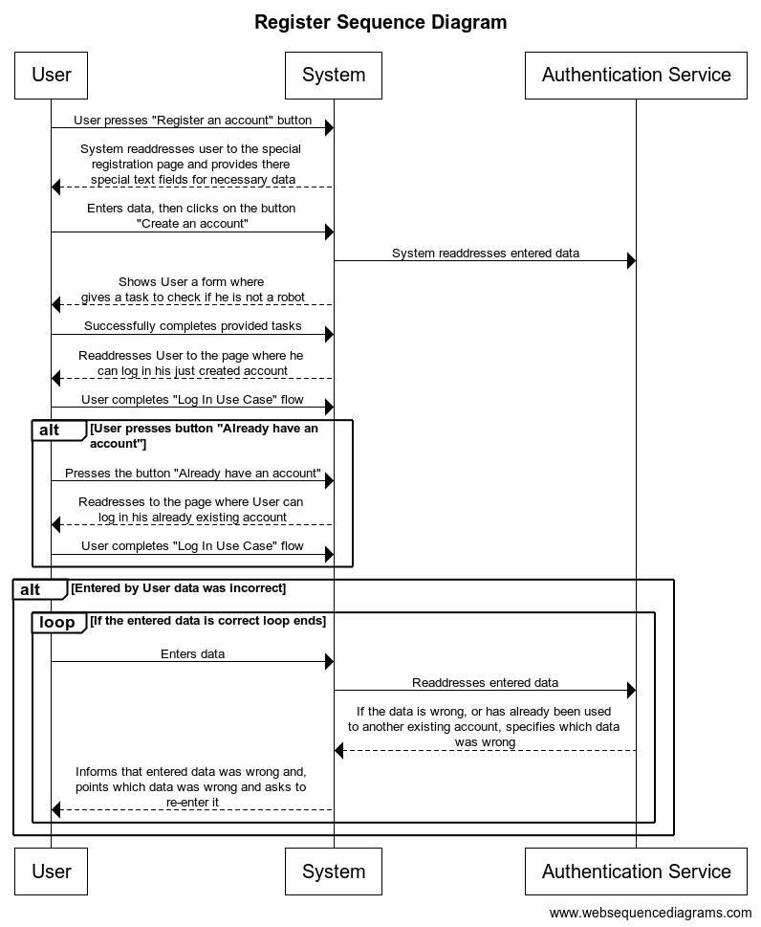

The “Register Sequence Diagram” outlines the user’s interaction with the system during account registration. It begins with the user initiating the process by pressing the “Register an account” button. The system redirects the user to a specialized registration page with designated text fields for necessary information. After data entry and submission by the user, the system verifies and adds the new user to the database through the Authentication Service. Upon successful registration, an anti-bot task is presented to confirm user authenticity. Upon task completion, the system redirects the user to the login page for the newly created account. The option to log in with an existing account is also provided, redirecting the user accordingly. In case of incorrect or duplicate data entry, a loop guides the user to rectify the erroneous information. This diagram comprehensively illustrates the registration process, including successful account creation, login options, and error handling for incorrect or duplicate data entry.

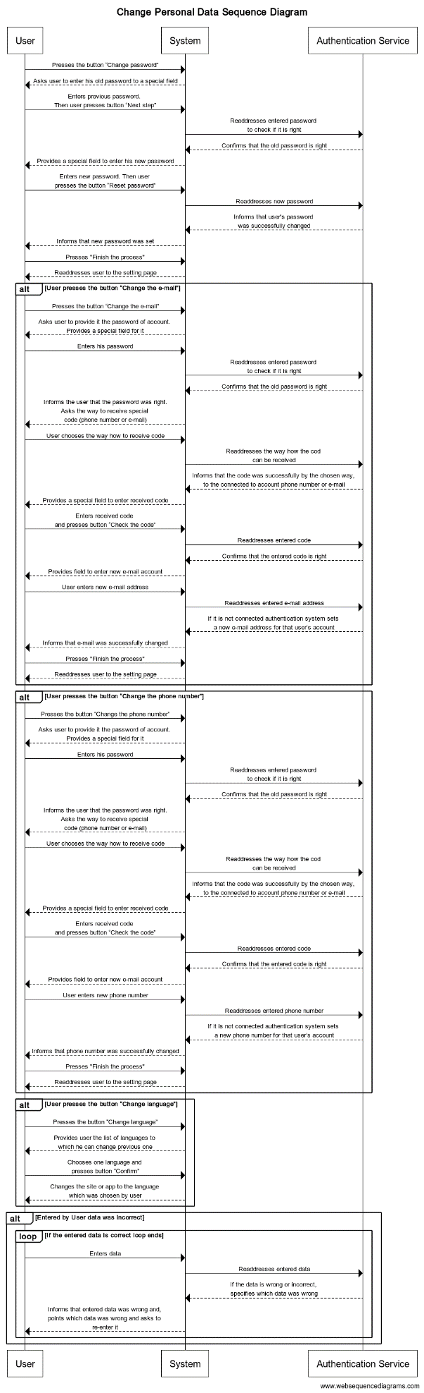

The “Change Personal Data Sequence Diagram” illustrates the user’s interactions for altering personal information within the system. Initiated by the user pressing the relevant option (“Change password,” “Change email,” “Change phone number,” or “Change language”), the system guides the user through specific steps for each action. For password changes, the user enters the old password, verifies it, sets a new password, and completes the process. Similarly, for email and phone number changes, the system verifies the old password, prompts the user to choose the method for receiving a code (email or phone), verifies the code, and updates the user’s details accordingly. Language change involves the user selecting a new language, and upon confirmation, the system switches the interface language. In case of incorrect data entry, a loop guides the user to rectify the erroneous information. This comprehensive diagram covers the processes for altering passwords, email, phone numbers, and language settings while accommodating error handling for incorrect data entries.

The “Create Post Sequence Diagram” details the process of a user creating a post within the system. Initiated by the user pressing the “Create Post” button, the system first verifies the user’s session. Upon a valid session, the system prompts the user to input post content. The user provides the content, which undergoes sanitization and validation by the system. If the content meets validation criteria, the system generates a unique post ID, timestamps the post, considers the user’s anonymity preferences, and stores the post in the database. A confirmation message, “Post Created Successfully,” is sent upon successful creation. In case of invalid content, the system sends a validation error message. Alternatively, if the session is invalid, the system sends an authentication error message. This sequence diagram encapsulates the steps involved in creating a post, from user initiation to content validation, storage, and error handling for both valid and invalid scenarios regarding the user session and content validation.

This Use-Case diagram shows actors that will interact with our system (user and Admin). It has 14 functional requirements with 10 allocated to the user and all 14 to the admin. Use-Case diagram depicts crucial functional requirements for different types of actors that will interact with our “EchoesForum - Online Chat and Forum Service system”. This Use-Case diagram has all necessary functional requirements such as register, login create posts, send message to a user, view thread and others for a user to properly use EchoesForum. Additionally, administrator of EchousForum are going to have more functionality with extra functional requirements such as remove threads, remove comments, remove posts and remove likes.